Experiment No. | 8
Aim | Branch and Bound Strategy
Name | Sakshi D Lonare
UID No. | 2021300069
Class & Division | Comps SE A

Algorithm:-

-> Start
- Declare variables m, n, a[10][10], t[10][10], temp[10][10], r[10][10], x, y, p, i, j, d, dmin, l and initialize m, n, l to 0 and d to a high value (e.g., 1000).
- Read the initial matrix a and goal state matrix t from the user.
- Display the initial and goal state matrices.
- While the initial matrix is not equal to the goal state matrix, do the following:
- Increment l.
- Set d to a high value (e.g., 1000).
- Find the location (x, y) of the blank space in the initial matrix.
- Create a copy of the initial matrix in temp.
- Move the blank space upwards by swapping the values at (x, y) and (x-1, y) in temp if x is not 0.
- Calculate the heuristic cost (i.e., the number of misplaced tiles) from temp to the goal state matrix t and store it in m.
- Calculate the sum of the heuristic cost and the depth of the node (i.e., l) and store it in dmin.
- If dmin is less than d, update d with dmin and copy the contents of temp to r.
- Repeat steps 10-13 for moving the blank space downwards, rightwards, and leftwards.
- Display the intermediate matrix value r.
- Copy the contents of r to a and clear the contents of temp.
- Repeat steps 5-16 until the initial matrix is equal to the goal state matrix.
- Stop.

Program:-
#include<stdio.h>
#include<conio.h>

int m=0,n=4;

int cal(int temp[10][10],int t[10][10])
{
int i,j,m=0;
for(i=0;i < n;i++)
for(j=0;j < n;j++)
{
if(temp[i][j]!=t[i][j])
m++;
}
return m;
}

int check(int a[10][10],int t[10][10])
{
int i,j,f=1;
for(i=0;i < n;i++)
for(j=0;j < n;j++)
if(a[i][j]!=t[i][j])
f=0;
return f;
}

void main()
{
int p,i,j,n=4,a[10][10],t[10][10],temp[10][10],r[10][10];
int m=0,x=0,y=0,d=1000,dmin=0,l=0;
printf("\nEnter initial matrix to be solved(zero for blank space):\n");
for(i=0;i < n;i++)
for(j=0;j < n;j++)
scanf("%d",&a[i][j]);

printf("\nEnter the goal state matrix(zero for blank space):\n");
for(i=0;i < n;i++)
for(j=0;j < n;j++)
scanf("%d",&t[i][j]);

printf("\nInitial Matrix is :\n");
for(i=0;i < n;i++)
{
for(j=0;j < n;j++)
printf("%d\t",a[i][j]);
printf("\n");
}

printf("\nGoal State Matrix is :\n");
for(i=0;i < n;i++)
{
for(j=0;j < n;j++)
printf("%d\t",t[i][j]);
printf("\n");
}

while(!(check(a,t)))
{
l++;
d=1000;
for(i=0;i < n;i++)
for(j=0;j < n;j++)
{
if(a[i][j]==0)
{
x=i;
y=j;
}
}

//upwards
for(i=0;i < n;i++)
for(j=0;j < n;j++)
temp[i][j]=a[i][j];

if(x!=0)
{
p=temp[x][y];
temp[x][y]=temp[x-1][y];
temp[x-1][y]=p;
}
m=cal(temp,t);
dmin=l+m;
if(dmin < d)
{
d=dmin;
for(i=0;i < n;i++)
for(j=0;j < n;j++)
r[i][j]=temp[i][j];
}

//downwards
for(i=0;i < n;i++)
for(j=0;j < n;j++)
temp[i][j]=a[i][j];
if(x!=n-1)
{
p=temp[x][y];
temp[x][y]=temp[x+1][y];
temp[x+1][y]=p;
}
m=cal(temp,t);
dmin=l+m;
if(dmin < d)
{
d=dmin;
for(i=0;i < n;i++)
for(j=0;j < n;j++)
r[i][j]=temp[i][j];
}

// right side
for(i=0;i < n;i++)
for(j=0;j < n;j++)
temp[i][j]=a[i][j];
if(y!=n-1)
{
p=temp[x][y];
temp[x][y]=temp[x][y+1];
temp[x][y+1]=p;
}
m=cal(temp,t);
dmin=l+m;
if(dmin < d)
{
d=dmin;
for(i=0;i < n;i++)
for(j=0;j < n;j++)
r[i][j]=temp[i][j];
}

//To move left
for(i=0;i < n;i++)
for(j=0;j < n;j++)
temp[i][j]=a[i][j];
if(y!=0)
{
p=temp[x][y];
temp[x][y]=temp[x][y-1];
temp[x][y-1]=p;
}
m=cal(temp,t);
dmin=l+m;
if(dmin < d)
{
d=dmin;
for(i=0;i < n;i++)
for(j=0;j < n;j++)
r[i][j]=temp[i][j];
}

printf("\nIntermediate Matrix Value :\n");
for(i=0;i < n;i++)
{
for(j=0;j < n;j++)
printf("%d\t",r[i][j]);
printf("\n");
}
for(i=0;i < n;i++)
for(j=0;j < n;j++)
{
a[i][j]=r[i][j];
temp[i][j]=0;
}
//printf("Minimum cost : %d\n",d);
}
getch();
}

Output:-
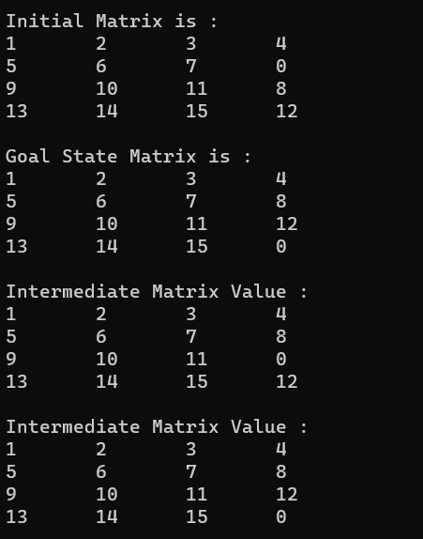

Conclusion: I learnt how to solve the 15 puzzle problem using branch and bound strategy strategy. The branch and bound strategy used in this program is effective in finding the optimal solution to the 15-Puzzle or even N-puzzle problem.

